Frequently Asked Questions (FAQs)

- Will the proposed change affect appointment availability or waiting times at Allied surgery?

No, there will be no impact to appointment availability or waiting times, and due to increased clinical consultation and treatment rooms available, we will be building on our clinical and administrative teams to ensure that we maximise our usage that the increased space at Preston Barracks will offer.

- Will I still be seen by the same GP and other clinical staff?

Yes, and as mentioned above, we will be building on our clinical and administrative teams to ensure that we maximise our usage that the increased space at Preston Barracks will offer

- Is there enough parking at Preston Barracks?

There will be designated disabled parking available at Preston Barracks and there is free on street parking available within the local area.

- What public transport is available for me?

Buses routes 24,25,48 and 49 can be used to attend Preston Barracks

Photo 1 is Mithras house - Northbound
Photo 2 is B&Q - Northbound
Picture 3 is Mithras house - Southbound

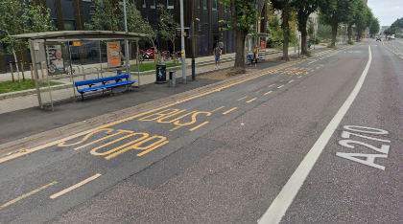
Photo 1 Photo 2 Photo3
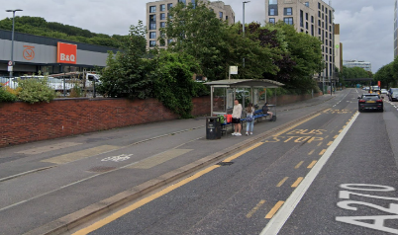
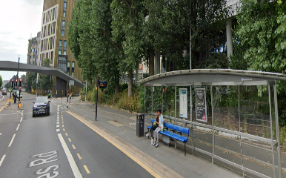

- I don’t drive, how can I attend appointments at an alternative surgery?

All appointments that require a face-to-face assessment will need to be attended at the new location as both School house surgery and Church surgery will be closed once the Preston Barracks site is fully operational.

- When and how will the final decision be made?

The ICB will be compiling a report based on the feedback received from the patient survey and engagement meetings currently underway and this will be shared as part of the evidence required for a decision at an ICB property committee in March.

- Can I choose to register with a different practice if I don’t want to travel to a new location?

We hope that patients will wish to remain registered with us when we relocate, however if you wish, then you can register with another GP practice, and these can be identified online at -
Find a GP - NHS
https://www.nhs.uk/service-search/find-a-gp

- Do I need to re-register if my surgery moves?

No, all patients will automatically remain registered under Allied Medical Practice at the new location.


- How can I share my views?

Please see below link to the survey which remains open until Monday 23rd March 2026

Stanford Medical Centre and Allied Medical Practice | NHS Sussex

